Russia-Ukraine War: The Crude Awakening
- The Russia-Ukraine war has led to higher market volatility. However, the cost of an extended war and severe sanctions are likely to choke Russia’s small economy.
- Despite a small economy, Russia has a significant contribution to global commodities, which could add to higher inflation. While this creates a quandary of competing forces of high inflation and a potential slowdown in growth from higher costs, the Federal Reserve (Fed) is likely to remain focused on inflation and begin raising interest rates.
- Historically, geopolitical events have been a humanitarian disaster, but have had a short-lived effect on markets.

The Russia-Ukraine war is a humanitarian disaster. While this latest insight focuses on the impact of the war on global economies and markets, in hopes for a resolution to this humanitarian crisis, be reminded of this quote by Franklin Delano Roosevelt: “More than an end to war, we want an end to the beginnings of all war”.
The Russian invasion of Ukraine has added to volatility in global markets in 2022. This latest volatility has led stocks to fall, while traditional safe havens like Treasuries and gold are rising. Oil prices have also spiked above $100 for the first time in seven years. While this situation is highly fluid and subject to change, here are some considerations for investors to navigate the latest market uncertainty.
Russia’s economy is small, and sanctions will further choke its economy
Russia’s presence as a large geopolitical nuclear armed power stands in contrast to the small size of its economy. Measured by gross domestic product, the most common yardstick for measuring a country’s economic size, Russia pales in comparison to the US and the Eurozone. As of 2020, Russia’s GDP stood at $1.48 trillion, in comparison to $1.78 trillion for the state of Texas and $20.9 trillion for the US economy.
US exports to Russia total $6 billion, which is materially insignificant given the size of the US economy. In addition, with the latest economic sanctions, the Russian currency is in a freefall, and its debt downgraded to junk status, the Russian economy will be further choked.
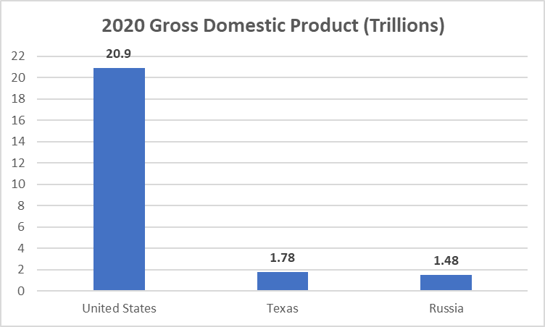
Source: World Bank, FRED
Similarly, within the stock markets, as of February 28, 2022, Russian equities represented 1.6% of the market cap weight of the emerging market index and 0.19% of the market cap weight of the global equity index. Russian equities have also been in a freefall, leading the stock exchange in the country to close since last week. Further, many of the majority equity index providers have indicated they plan to remove Russian listings from key indexes next week, a further blow to its economy.
Energy price spike adds to inflation pressure
Even though Russia’s economic profile is small, it does significantly contribute to global commodity production. Within the energy complex, Russia supplies 17% of natural gas and 12% of crude oil. This puts Russia as the world’s third-largest producer of oil and second-largest producer of natural gas.
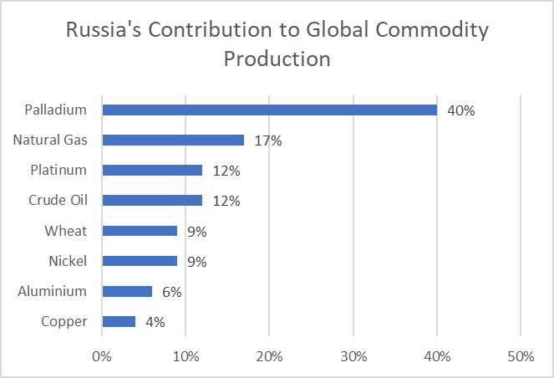
Russia also has meaningful contributions in various other commodities as shown below. As Russia’s supply of these various commodities becomes constrained, this will continue to put pressure on supply chains, adding further to inflationary pressures and a drag on global growth. The threat to Europe’s economy is far greater given its proximity to the region and its greater reliance on Russian energy. The bottom line is increased inflationary pressure could lead to more volatility.
Source: JPMorgan Asset Management. Should I worry about Russia/Ukraine tensions impacting markets?
Higher inflation and increased market volatility put the Fed in a bind. The Fed may hike faster than expected due to increased inflationary pressure, or it could hold off if the potential rising costs of energy slows the economy. With US inflation hitting a 40-year high and a war-related energy spike, Fed officials are limited in their options and will likely continue with interest rate hike moves at the upcoming March meeting and remain consistent with prior messaging.

Geopolitical impacts on markets are not new
The Russia-Ukraine war undoubtedly complicates the near-term market outlook. That said, history shows that geopolitical crises tend to have short-lived market impacts unless they lead to a recession. A study of historical geopolitical events shows the S&P 500 was higher 12 months later in nine of the 12 events. The three instances where stocks were down a year later coincided with a recession. Today, an extended conflict increases the likelihood of a slowdown in the US economy, but the risk of a U.S. recession remains low. Cash balances for consumers and businesses remain robust and, the job market continues to remain resilient.
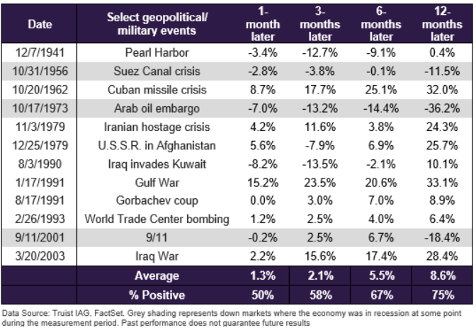
Geopolitical risks are sadly a wildcard in investing and nearly impossible to forecast. Amidst this uncertainty, global markets will remain choppy in the near term. This, however, should not change most investors’ long-term plans. As difficult as it might be, sticking to one’s investment plan and staying put with a diversified portfolio might be the best course of action when faced with uncertainty and volatility.

IMPORTANT INFORMATION
This is for informational purposes only, is not a solicitation, and should not be considered investment, legal or tax advice. The information in this report has been drawn from sources believed to be reliable, but its accuracy is not guaranteed, and is subject to change. Investors seeking more information should contact their financial advisor. Financial advisors may seek more information by contacting AssetMark at 800-664-5345.
Investing involves risk, including the possible loss of principal. Past performance does not guarantee future results. Asset allocation cannot eliminate the risk of fluctuating prices and uncertain returns. There is no guarantee that a diversified portfolio will outperform a non-diversified portfolio. No investment strategy, such as asset allocation, can guarantee a profit or protect against loss. Actual client results will vary based on investment selection, timing, market conditions, and tax situation. It is not possible to invest directly in an index. Indexes are unmanaged, do not incur management fees, costs and expenses and cannot be invested in directly. Index performance assumes the reinvestment of dividends.
Investments in equities, bonds, options, and other securities, whether held individually or through mutual funds and exchange traded funds, can decline significantly in response to adverse market conditions, company-specific events, changes in exchange rates, and domestic, international, economic, and political developments.
AssetMark, Inc. is an investment adviser registered with the U.S. Securities and Exchange Commission. AssetMark and third-party service providers are separate and unaffiliated companies. Each party is responsible for their own content and services.
©2022 AssetMark, Inc. All rights reserved.
103305 | C22-18578 | 03/2022 | EXP 03/31/2024

AssetMark, Inc.
1655 Grant Street
10th Floor
Concord, CA 94520-2445
800-664-5345

https://www.reuters.com/business/energy/oil-extends-gains-above-90bbl-winter-storm-sweeps-through-united-states-2022-02-04/
https://fred.stlouisfed.org/series/TXNGSP
https://data.worldbank.org/indicator/NY.GDP.MKTP.KD.ZG
Wells Fargo Economics: Some implications of the war between Russia and Ukraine
Ned Davis Research: Sizing up the U.S. economic exposure to Russia
https://www.ssga.com/us/en/intermediary/etfs/insights/questions-emerging-from-the-russia-ukraine-conflict
https://www.msci.com/eqb/pressreleases/archive/PR_Russia_Classification.pdf
https://am.jpmorgan.com/us/en/asset-management/adv/insights/market-insights/market-updates/on-the-minds-of-investors/should-i-worry-about-russia-ukraine-tensions-impacting-markets/
https://www.truist.com/content/dam/truist-bank/us/en/documents/article/wealth/insights/market-perspective-02-14-22.pdf
https://www.bls.gov/news.release/empsit.nr0.h

